Form – Expression of Interest for Funding
  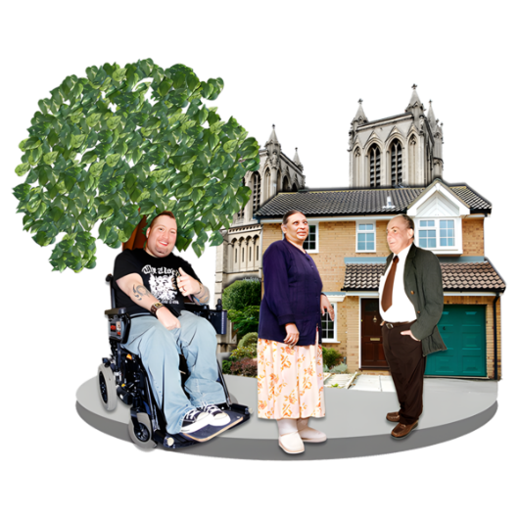 | - Contents  - Eligibility Check  Eligibility means:  - You fit the rules the foundation has  - The foundation will decide if they give you money  - You may get funding if you meet the criteria  - Section 1: About you  - This helps us contact you.  - Section 2: About your group  - In this form, group refers to a community group or organisation.  - Section 3: Your initiative  - An initiative is a plan to do something new and helpful.
  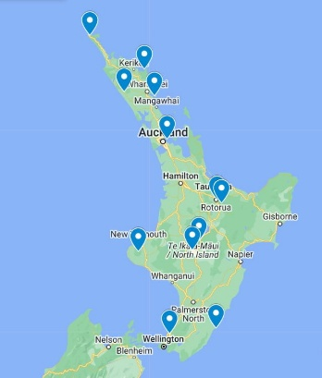       | - Eligibility Check  Check the box if you agree:  ☐My group is based in the North Island of New Zealand  ☐My group is “not for profit”  Not for profit means:  - It uses money to help people.  - It does not try to make money for itself.  - Any extra money is used to do more good things.  ☐My group works in disability.  ☐You want to ask for some funding.  The ‘funding’ is some money from Spectrum Foundation.  If you checked all the boxes:  You can keep filling out the form.  If you are unsure:  - You can contact us at info@spectrumfoundation.org.nz  - Or 09 634 3790

- About You
Write or type in the grey boxes.

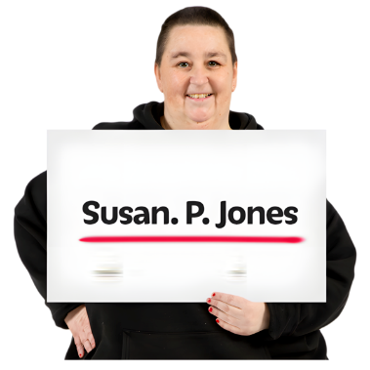 | What is your name?
 | - What is your role in your group?
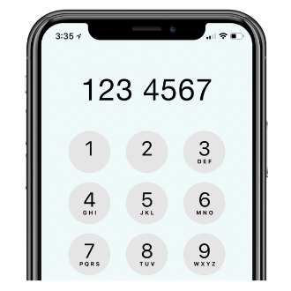 | What is your phone number?
 | What is your email?
- About your Organisation
Write or type in the grey boxes.

 | What is the name of your organisation?
 | Is it a charity or a group?
 | Where is your head office?
 | What is your website address?
 | What are your social media pages?
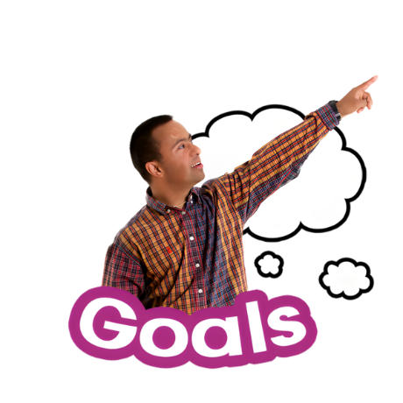 | What is your group’s goal?

- Your Initiative
Write or type in the grey boxes.

 | What is the name of the programme you want funding for?
 | Where will the programme be located?
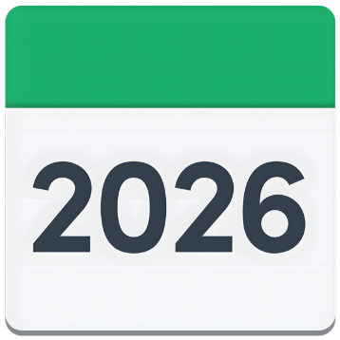 | If you already know:  - When will the programme start?  - When will the programme finish?
 | What group of people are you helping?
 | How much money do you need?
If you have it:
You can send us a document with your budget details
We want to know how your work helps disabled people.
This includes:
- Respect (mana)
- Choice and control
 | Please choose what is true:  ​​ ☐ ​People with lived experience are leaders  ​​ ☐ ​People with lived experience help make decisions  ​​ ☐ ​Your work helps people have more independence or choice  ​​ ☐ ​Other
Note:
Lived experience can include:
- Disabled people
- Whānau (family)

 | Tell us more about how you do this:
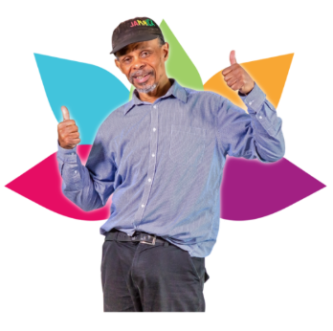 | Choose 1 or more priority area that your group is working in:  ​​ ☐ ​Health and wellbeing  ​​ ☐ ​Education  ​​ ☐ ​Employment  ​​ ☐ ​Housing  ​​ ☐ Other
 | Is there anything else you want to tell us about your programme?
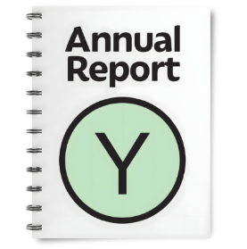 | Please send your latest financial information.  You can send:  - A report (like Profit and Loss or Cash Flow), or  - A file from Xero or a similar system, or  - A spreadsheet
 | Thank you.  Please email your:  finished form  Supporting documents to: info@spectrumfoundation.org.nz
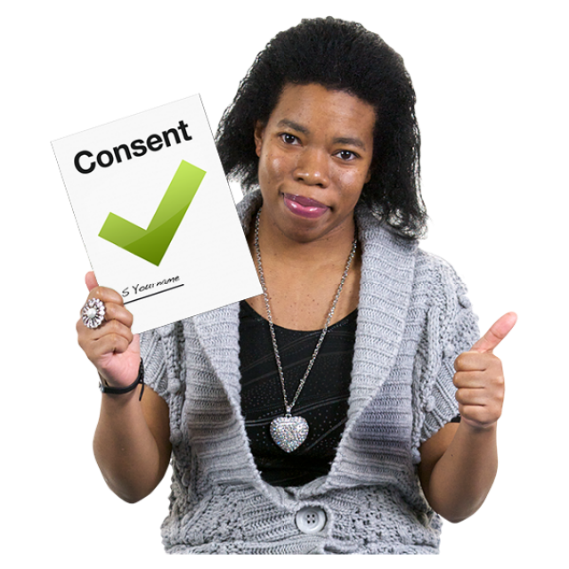 | Sharing your information  - Spectrum Foundation sometimes works with other funders.  - They may share your application with these funders.  Please tell us if you agree.  Your choice  ☐Yes, I agree to share my information  ☐No, I do not agree to share my information
   | Images from the Photosymbols Photo Library, copyright Photosymbols
Easy-read SF template last updated: 28 July 2025
Who is this for? Easy Read is an alternative format. It is used to make written information more accessible for people with learning disability and others who find standard written information difficult to understand. Please use this Easy Read form if you need it to request funding from Spectrum Foundation. Fill it in and send it back to the team who will add it into the funding portal.

